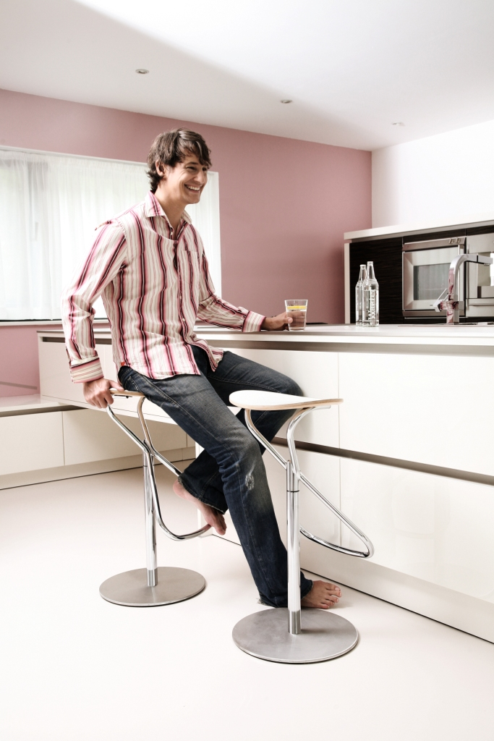

UNBOXED/ ex-display

KFF® Rodeo bar stool $......